**FUND MOBILIZATION PRODUCTS OF VPB FC**

*VPBank Finance Company Limited – VPB FC (FE CREDIT Brand)* *mobilizes fund by issuing* ***Certificate of Deposit (CSs****) and* ***Term Deposit (TD)****,**applying for* ***Vietnamese Organizations and International Organizations*** *with flexible tenor and attractive interest rates as listed below:*

|  |  |
| --- | --- |
| ***Tenor*** | ***Interest rate (%/pa)***  ***(interest paid at Maturity)*** |
| *Non term* | 1.00 |
| *From 01 month to below 03 months* | 5.25 |
| *From 03 month to below 06 months* | 5.50 |
| *From 06 month to below 09 months* | 8.00 |
| *From 09 month to below 12 months* | 8.25 |
| *12 months* | 8.75 |
| *From 12 month to below 15 months* | 9.00 |
| *From 15 month to below 18 months* | 9.25 |
| *From 18 month to below 24 months* | 9.50 |
| *24 months* | 10.00 |

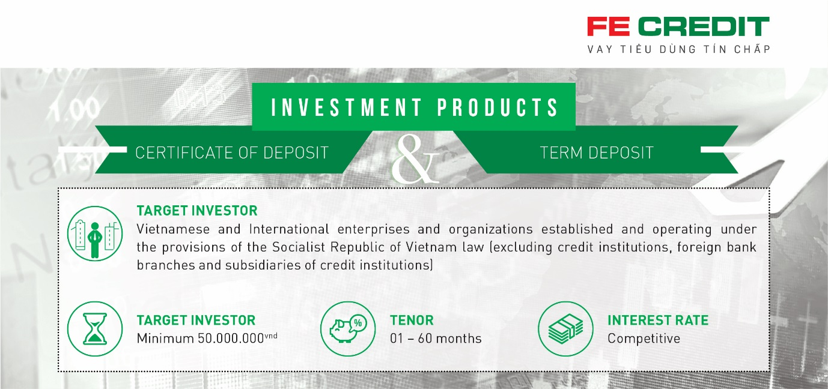

**For more information, please contact:**

VPBank Finance Company Limited – VPB FC (FE CREDIT Brand)

Treasury Center

Address: 15th Floor, E.Town Central Building, 11 Doan Van Bo Street, W. 12, D. 4, HCMC

Email: treasury@fecredit.com.vn

Website: https://fecredit.com.vn/en/for-investors/

Tel: (028) 39 115 212